**TO know about postman: -**

**Postman**is an API testing tool

**To select required Method**

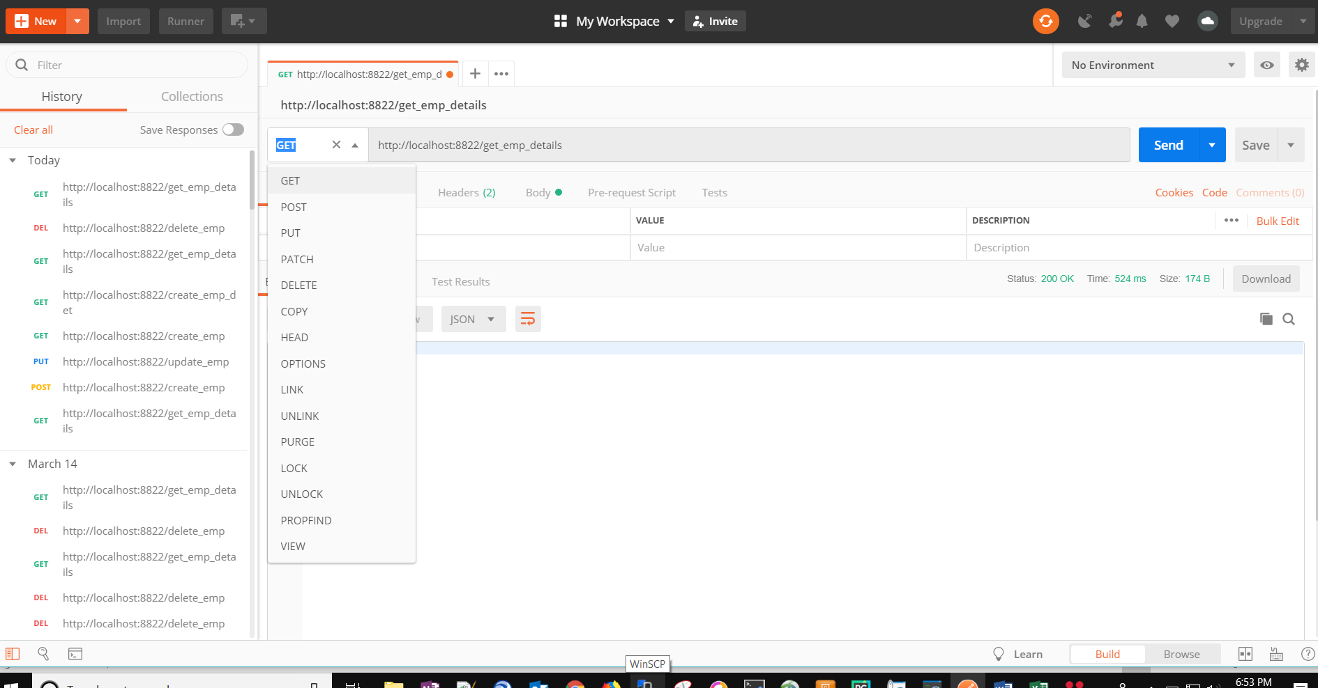

**To Pass credentials if required: -**

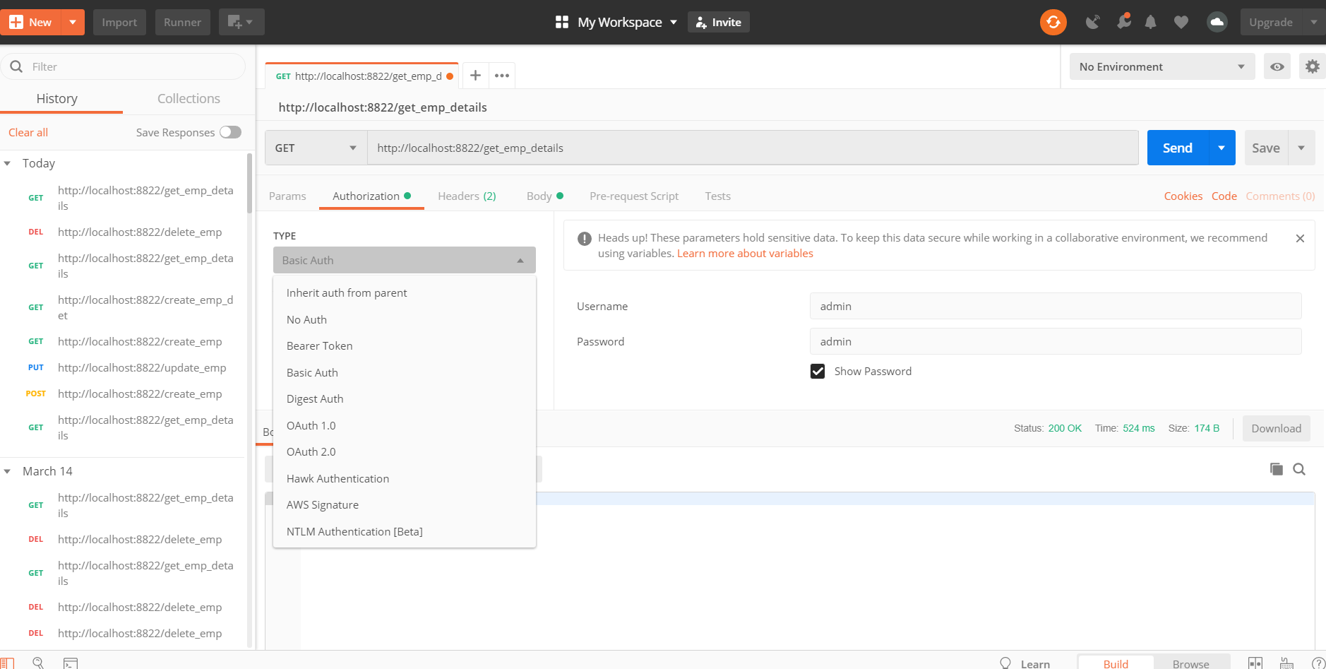

**To Send request data: -**

